**QF 604 – Econometrics of Financial Markets**

**The Dow Jones Utility Average & Possible Smart Beta Alternatives**

**Team Members:** Jin Weiguo, Kim Chan-Jung, Johnny Quek, Wang Boyu, Woon Tian Yong

**Section 1: Introduction**

The Dow Jones Utility Average (DJUA), started back in 1929, is one of the Dow Jones index groups that tracks the performance of a small group of 15 utility stocks traded in the United States by using a price-weighted average method. These companies predominately are producers of utility resources such as electricity and natural gas. In addition, these utility companies typically have sizable and steady stream of dividends pay-out than other sectors as they face less uncertainty and minimal future volatility due to nature of the utility industry. This therefore results in utility sector to be seen as a favourite for retirees and other income investors.

In hope to construct a much superior index that outperforms the original DJUA price-weighted one, our team decided to construct a smart-beta index by analysing several key fundamental factors of the individual companies to sieve out the most optimal one. This factor would then be used as the smart-beta factor for the formation of a smart-beta index.

**Section 2: Data Sources & Preparation**

Our data sample includes stock and relevant fundamentals data on all stocks which have ever been members of the Dow Jones Utility Average index for the period between 1963 and 2018 (the sample period). We obtained the bulk of our data from Wharton Research Data Services (WRDS), from which the Center for Research in Security Prices (CRSP), Compustat - Capital IQ and CRSP/Compustat Merged Database (CCM) databases were utilised. We also tapped on the Bloomberg database for membership data on the Dow Jones Utility Average, though the information provided was incomplete and was supplemented by information from [this article by Global Financial Data](https://www.globalfinancialdata.com/GFD/Article/a-brief-history-of-the-dow-jones-utility-average).

**Center for Research in Security Prices (CRSP)**

The Center for Research in Security Prices (CRSP) provided us with relevant data on the monthly closing price, adjusted returns and outstanding number of stocks. We used PERMCOs and PERMNOs as unique entity and issue identifiers when navigating the CRSP database.

**Compustat - Capital IQ**

Compustat provided us with the relevant fundamentals data (e.g. Net Income, Operating Cash Flow etc) on the relevant constituent stocks of the Dow Jones Utility Average. We used GVKEY as unique entity-level identifiers when navigating the Compustat database.

**CRSP/Compustat Merged Database (CCM)**

We used the CCM Database to obtain the links between the unique PERMCO and GVKEY identifiers for the CRSP and Compustat databases respectively. This allowed us to be able to link stock price and market capitalisation data to other corresponding fundamentals (e.g. computed ROCE, ROA numbers) data at the entity level. With that said, not all required data was found to be available for our sample period.

**Computation of Fundamentals**

Using data obtained from both CRSP and Compustat, the following 10 selected fundamentals were then computed for each eligible company for each year:

|  |  |  |  |  |
| --- | --- | --- | --- | --- |
| **Description** | **Equation** | **Price Return Index** | **Total Return Index** | **Comments** |
| Market Capitalisation | Share Price x No. of Shares Outstanding | Yes | Yes |  |
| Return on Assets | Net Income/Total Assets | Yes | Yes |  |
| Return on Capital Employed | EBIT/Capital Employed | Yes | Yes | Capital Employed = Total Assets - Current Liabilities |
| Return on Invested Capital | NOPAT/Invested Capital | Yes | Yes | NOPAT = EBIT x (1-Tax Rate) |
| Gross Margin | Gross Profit/Revenue | Yes | Yes |  |
| Profit Margin | Net Income/Revenue | Yes | Yes |  |
| EBITDA Margin | EBITDA/Revenue | Yes | Yes |  |
| Operating Cash Flow Margin | Operating Cash Flow/Revenue |  | Yes |  |
| Current Ratio | Current Assets/Current Liabilities | Yes | Yes |  |
| Long Term Debt to Total Equity | Long Term Debt/Total Equity | Yes | Yes |  |

**Section 2: Smart Beta Index Construction, Methodology & Initial Findings**

We then proceeded to construct smart beta indices based on the 10 fundamentals we have selected. Our weighting method is as follows:

$$w_{i,t}=\frac{f_{i,t-1}}{\sum_{i=1}^{N≤15}{f_{i,t-1}}}, \sum_{i=1}^{N≤15}{w_{i,t}}=1$$

where $w_{i,t}$ is the weight assigned for stock $i$ for trading year $t$, based on its fundamentals data from fiscal year $t-1$, where the sum of the weights of the individual stocks for any year is 1. For every year, only stocks of companies which were officially members of the benchmark index (the Dow Jones Utility Average) were included in this weighting process. In the case of the problem of missing data encountered for certain eligible companies in certain years, said companies will be excluded from the Index for that year ($w_{i,t}=0$). For that reason, our constructed indices may have less than 15 constituent stocks for some years, but never more than 15 constituent stocks for any year (as with the benchmark index).

Our constructed price and total return smart beta indices were first constructed on June 1963 and June 1988 respectively, with rebalancing taking place every year at the end of June. The weighting approach using fundamentals data from fiscal year $t-1$ for weights for trading year $t$, coupled with our approach of performing annual rebalancing only in end-June allows for the real-world replication of our smart beta indices based on known values at the time, as full fiscal year fundamentals data are usually only released at the end of Q1 of every calendar year.

Further, we only started our smart beta total returns indices from June 1988 owing to a lack of prior price data on the relevant benchmark index (the Dow Jones Utility Average Total Return) and on Operating Cash Flow Margin fundamentals data. As can be inferred, owing to a lack of data, price return smart beta indices based on Operating Cash Flow Margin were not constructed.

Given how some of our chosen fundamentals (e.g. ROA, ROCE, ROIC etc) can take on negative values, we allowed our indices to be fully unconstrained. This means that long or short positions on eligible stocks were permitted with no set limits. We also established an “absorbing state” for the prices of the smart beta indices to be at 0 (indicating a total loss of initial capital), with any of our indices reaching or exceeding that floor deemed to be failed ones and as such excluded from further analysis. Our constructed smart beta indices

**Initial Findings**

The superior smart beta index become clear as day after the computed smart beta index prices were plotted over time. For both price return and total return smart beta portfolios, the portfolios with ROIC-based weightings achieved far superior returns over our other constructed indices.

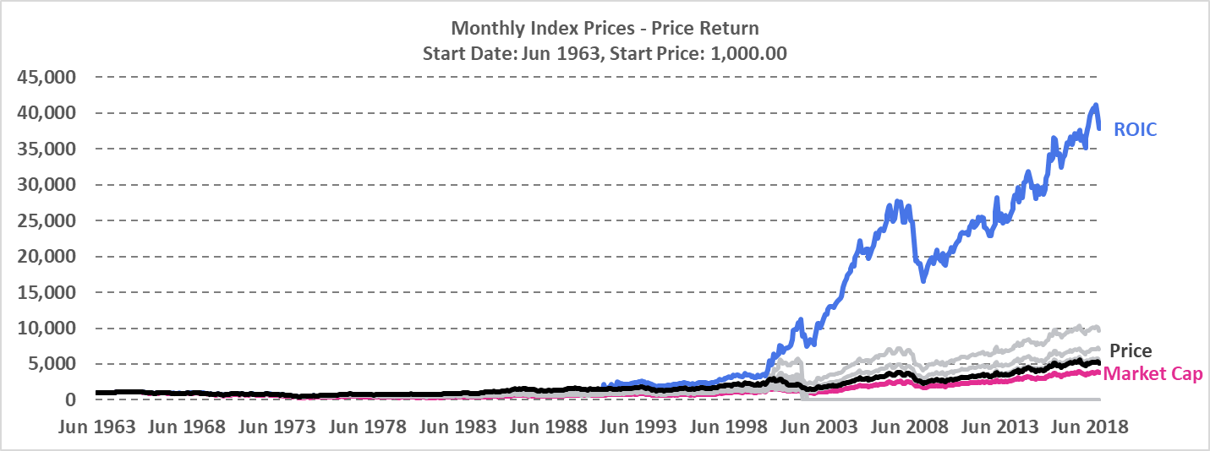

To put things into perspective, the value of $1 invested in our constructed ROIC-based total return smart beta portfolio at Jun 1988 would be worth $197.10 at the end of 2018 (excluding transaction costs), while an identical $1 invested in the benchmark total return index over the same time period would be worth “only” $15.77.

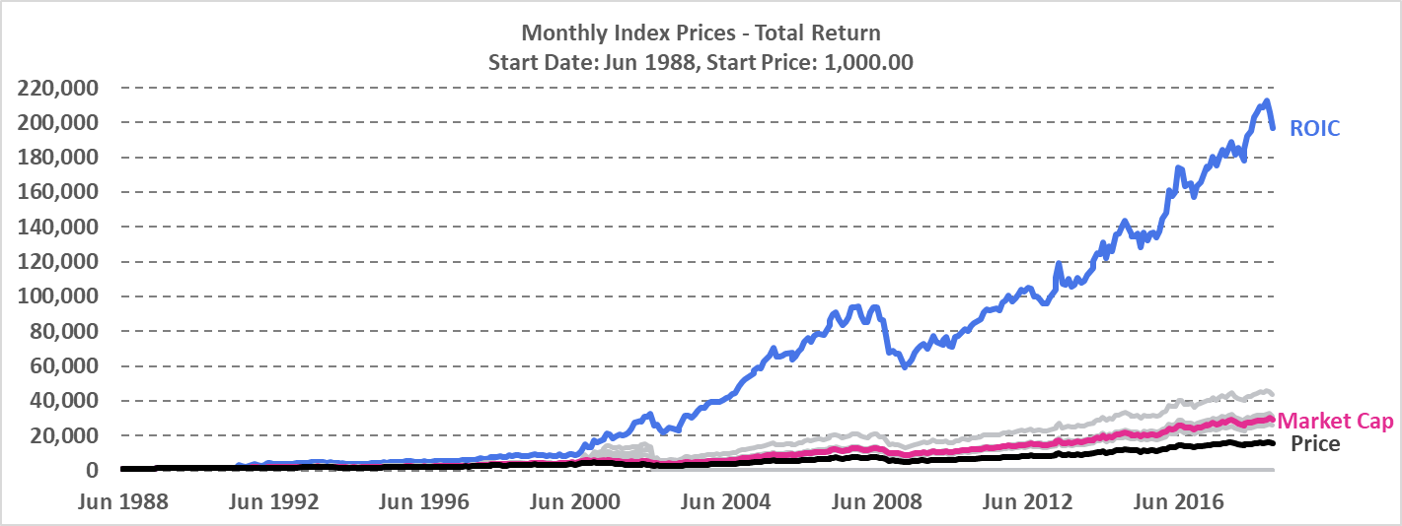

For our constructed price return indices, coming in as faraway second and third place were the ROCE and Current Ratio-based smart beta indices. Amongst the portfolios which survived the sample period, indices weighed based on price and market capitalisation performed the worst.

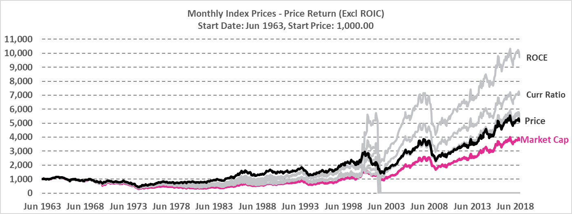

As with the case of the constructed price return indices, the second-best performing portfolio was the one weighted based on ROCE, with the Operating Cash Flow Margin-based index coming in third. The price-weighted index was once again amongst the worst performing but surviving ones.

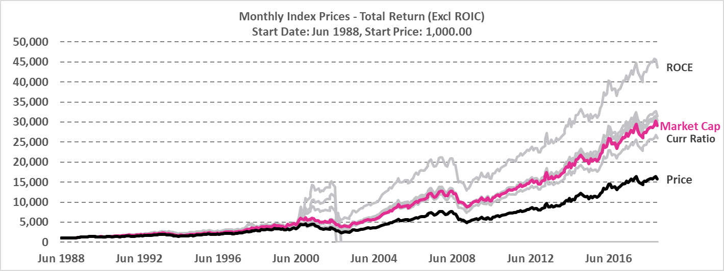

We also observed a few constructed portfolios which have failed over our sample period, namely the ones with weight allocations based on ROA, Profit Margin and LTDE Ratio.

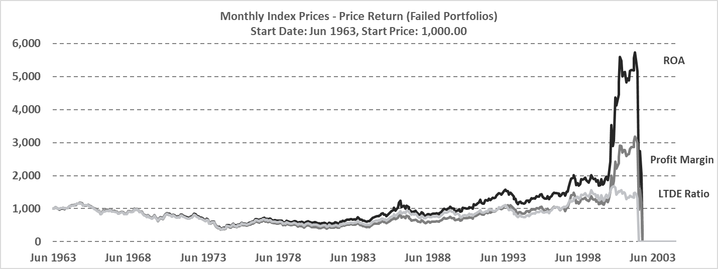

All of the failure cases were the result of a few extensive (and sometimes successive) losses incurred from prescribed unprofitable and extremely large short positions taken on the same few constituent stocks, the result of one of the drawbacks that come with allowing fully unconstrained portfolios. The failures were also observed to all have occurred in mid-to-late 2002.

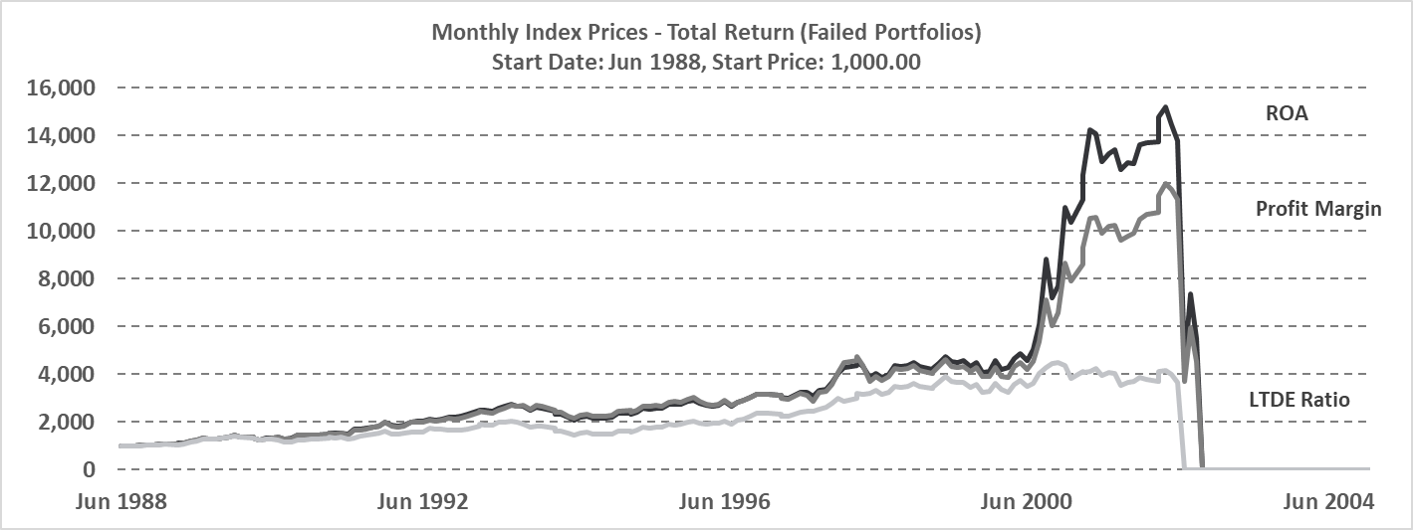

Failed constructed portfolios were excluded from further analysis.

**Section 3: Index Performance Appraisal**

**Section 3.1 Geometric Monthly Return**

Table 1 and Table 2 show the performance of the original Dow Jones Utility Index and alternative fundamental indices for price return from July 1961 to December 2018 and total return from July 1988 to December 2018, respectively.

Of particular note from the tables is that most of the fundamental indices in price return fail to generate excessive returns over Dow Jones Utility Average (DJUA) that are statistically indifferent from zero, whereas most total return fundamental indices manifest statistically significant outperformance over DJUA with an average t-statistic of 2.93. This seems to be due to the fact that the utility index consists mainly of stable stocks that earn profit from dividends rather than stock price rises; the average geometric return of total return indices is nearly three times higher than that of price return indices. For the same reason, most of price return indices underperformed risk-free rate during the observed period.

In the suggested ten fundamental metrics, Market Capitalisation is related to the size of firms and remaining metrics are about profitability ratio or balance sheet ratio. It is interesting that all the metrics except for Current Ratio of total return outperformed Market Capitalisation in terms of geometric return. It implies that perhaps profitability ratios are superior to firm size-related indicators, if the goal is to attain possible maximum return.

It is noticeable that ROIC is the only metric that produces statistically significant outperformance over the original indices in both price return and total return, having t-statistics of 1.80 and 2.17 for each return. Although ROIC does not render the largest Sharpe Ratio and Information Ratio for total return owing to its high volatility, ROIC has unrivaled profitability among the various indicators. The monthly geometric return of ROIC is as high as about 1.5 times of average geometric return for both price and total returns.

**Table 1 Monthly Performances of Fundamentally Weighted Price Return Indices, Jan 1964 - Dec 2018**

|  |  |  |  |  |  |  |  |  |  |
| --- | --- | --- | --- | --- | --- | --- | --- | --- | --- |
| Index | Ending Value of 1$ | Geometric  Return | Volatility | VS RF rate  (3M US Treasury) | | | VS Original Index | | |
| **Excess Return** | **Sharpe Ratio** | **t-Stats\*** | **Excess Return** | **Information Ratio** | **t-Stats\*** |
| DJUAPR | $ 5.14 | 0.25% | 4.14% | -0.14% | -3.31% | -0.31 | - | - | - |
| ROIC  (Return on Invested Capital) | $ 37.61 | 0.55% | 7.73% | 0.16% | 2.12% | 1.32 | 0.31% | 4.80% | 1.80 |
| ROCE  (Return on Capital Employed) | $ 9.67 | 0.34% | 4.79% | -0.04% | -0.87% | 0.39 | 0.10% | 4.71% | 1.48 |
| Gross Margin | $ 5.52 | 0.26% | 4.53% | -0.13% | -2.79% | -0.13 | 0.01% | 0.66% | 0.40 |
| EBITDA Margin | $ 5.34 | 0.25% | 4.51% | -0.13% | -2.92% | -0.16 | 0.01% | 0.34% | 0.32 |
| Current Ratio | $ 6.99 | 0.30% | 4.49% | -0.09% | -2.02% | 0.07 | 0.05% | 2.65% | 0.90 |
| Market Capitalisation | $ 3.77 | 0.20% | 4.53% | -0.18% | -4.07% | -0.46 | -0.05% | -2.56% | -0.41 |
| Average | $ 10.58 | 0.31% | 4.96% | -0.08% | -1.98% | 0.10 | 0.07% | 1.77% | 0.75 |

* One-tail critical t-statistics is 1.65

**Table 2 Monthly Performances of Fundamentally Weighted Total Return Indices, Jan 1989 - Dec 2018**

|  |  |  |  |  |  |  |  |  |  |
| --- | --- | --- | --- | --- | --- | --- | --- | --- | --- |
| Index | Ending Value of 1$ | Geometric  Return | Volatility | VS RF rate  (3M US Treasury) | | | VS Original Index | | |
| **Excess Return** | **Sharpe Ratio** | **t-Stats\*** | **Excess Return** | **Information Ratio** | **t-Stats\*** |
| DJUATR | $ 6.16 | 0.75% | 4.17% | 0.51% | 12.14% | 2.70 | - | - | - |
| ROIC  (Return on Invested Capital) | $ 181.77 | 1.46% | 9.32% | 1.21% | 13.03% | 3.11 | 1.07% | 12.78% | 2.17 |
| ROCE  (Return on Capital Employed) | $ 40.60 | 1.03% | 4.78% | 0.79% | 16.60% | 3.58 | 0.65% | 26.65% | 3.20 |
| Gross Margin | $ 28.79 | 0.94% | 4.45% | 0.69% | 15.60% | 3.38 | 0.55% | 27.29% | 3.11 |
| EBITDA Margin | $ 28.19 | 0.93% | 4.42% | 0.69% | 15.60% | 3.38 | 0.54% | 27.36% | 3.10 |
| Operating Cash Flow Margin | $ 29.46 | 0.94% | 4.21% | 0.70% | 16.66% | 3.55 | 0.55% | 29.43% | 3.38 |
| Current Ratio | $ 24.56 | 0.89% | 4.44% | 0.65% | 14.65% | 3.20 | 0.51% | 25.58% | 2.34 |
| Market Capitalisation | $ 26.76 | 0.92% | 4.19% | 0.67% | 16.10% | 3.44 | 0.52% | 29.41% | 3.23 |
| Average | $ 45.79 | 0.98% | 5.00% | 0.74% | 15.05% | 3.29 | 0.63% | 25.50% | 2.93 |

* One-tail critical t-statistics is 1.65

As is shown in Table 3 and Table 4, Market Capitalisation, the only size metric has the smallest absolute value in skewness, and the third smallest absolute value in kurtosis for both price and total return. This means that return distribution of Market Capitalisation index is almost symmetrical and has thin tail, which is also in line with the low volatility of Market Capitalisation index. Most of profitability ratio and balance sheet ratio indices are more exposed to big downside risk than Market Capitalisation or the original index is.

ROIC has extremely high absolute values for kurtosis. The fact that ROIC has fat tails in their distributions can also be seen in its relatively large maximum and minimum return. Nevertheless, having fat tail does not necessarily make ROIC bad. ROIC has large positive value – 8.30 and 8.43 respectively for price return and total return - as its skewness, which means we are more likely to enjoy upside potential from these indices than to suffer from downside risk. As a matter of fact, maximum return is nearly four times greater than minimum monthly return in absolute term for 1-month, 3-month, and 12-month returns. This also accords with that ROIC is the most profitable index in Table 1 and 2.

**Table 3 Distribution of Fundamentally Weighted Price Return Indices, Jan 1964 - Dec 2018**

|  |  |  |  |  |  |  |  |  |
| --- | --- | --- | --- | --- | --- | --- | --- | --- |
| Index | Skewness | Kurtosis | Maximum Monthly Return | Minimum Monthly Return | Maximum 3-Month Return | Minimum  3-Month Return | Maximum 12-Month Return | Minimum  12-Month Return |
| DJUAPR | -0.23 | 0.82 | 13.41% | -16.02% | 27.68% | -24.55% | 46.70% | -41.68% |
| ROIC | 8.30 | 138.22 | 134.33% | -30.60% | 125.15% | -27.62% | 161.42% | -43.59% |
| ROCE | 0.26 | 2.48 | 27.47% | -17.66% | 55.88% | -28.14% | 100.79% | -41.76% |
| Gross Margin | -0.20 | 1.35 | 16.88% | -21.34% | 40.09% | -30.76% | 62.44% | -44.46% |
| EBITDA Margin | -0.18 | 1.19 | 16.88% | -20.12% | 37.60% | -28.96% | 56.73% | -44.46% |
| Current Ratio | -0.21 | 1.67 | 19.25% | -21.33% | 39.49% | -34.02% | 67.16% | -44.29% |
| Market Capitalisation | -0.02 | 1.22 | 19.44% | -17.65% | 34.76% | -30.31% | 58.32% | -49.46% |
| Average | 1.11 | 20.99 | 35.38% | -20.68% | 51.52% | -29.19% | 79.08% | -44.24% |

**Table 4 Distribution of Fundamentally Weighted Total Return Indices, Jul 1988 - Dec 2018**

|  |  |  |  |  |  |  |  |  |
| --- | --- | --- | --- | --- | --- | --- | --- | --- |
| Index | Skewness | Kurtosis | Maximum Monthly Return | Minimum Monthly Return | Maximum 3-Month Return | Minimum  3-Month Return | Maximum 12-Month Return | Minimum  12-Month Return |
| DJUAPR | -0.48 | 0.55 | 12.39% | -13.33% | 30.78% | -21.63% | 51.65% | -31.80% |
| ROIC | 8.43 | 117.26 | 134.84% | -28.59% | -26.87% | -26.87% | 194.69% | -32.58% |
| ROCE | 0.29 | 3.80 | 27.36% | -17.55% | 57.59% | -27.47% | 108.80% | -33.09% |
| Gross Margin | -0.57 | 1.98 | 15.83% | -21.26% | 40.81% | -30.14% | 67.14% | -33.25% |
| EBITDA Margin | -0.53 | 1.63 | 14.40% | -20.04% | 38.39% | -28.33% | 61.74% | -31.42% |
| Operating Cash Flow Margin | -0.43 | 0.68 | 13.93% | -13.00% | 33.52% | -22.70% | 52.94% | -32.84% |
| Current Ratio | -0.58 | 2.15 | 15.34% | -21.28% | 40.26% | -33.44% | 71.58% | -37.54% |
| Market Capitalisation | -0.14 | 1.14 | 19.37% | -11.18% | 35.80% | -22.07% | 63.38% | -27.70% |
| Average | 0.75 | 16.15 | 31.68% | -18.28% | 31.28% | -26.58% | 83.99% | -32.53% |

**Section 3.2 Arithmetic Annual Return**

The table below summarizes arithmetic annual price returns for the six fundamental-weighted indexes. Except for ROIC-weighted index, other indexes are capped by 6% annually with Market cap gives the lowest annual figure of 3.91%. ROIC-weighted index, despite of its highest volatility, performs the best in terms annual return and sharpe ratio. It has the best monthly return, most positive monthly returns and worst monthly return. Its lower than average correlation (0.64) with DJU implies its exceptional return cannot be explained by the benchmark, which makes ROIC-weighted index the best performer among all the fundamentals between 1964-2018.

|  |  |  |  |  |  |  |  |
| --- | --- | --- | --- | --- | --- | --- | --- |
|  | **Price Return (Arithmetic)** | | | | | | |
| Jan 1964- Dec 2018 | DJU | ***Market Cap*** | **ROIC** | ROC | Gross Margin | EBITDA Margin | Curr Ratio |
| **Annual return** |  |  |  |  |  |  |  |
| Average Annual Return (%) | 4.34% | ***3.91%*** | **9.47%** | 5.89% | 4.68% | 4.55% | 5.20% |
| Annual Volatility (%) | 16.31% | ***17.38%*** | **27.20%** | 19.49% | 17.71% | 17.27% | 18.17% |
| Average Annual Risk Free Rate (%) | 4.78% | ***4.78%*** | **4.78%** | 4.78% | 4.78% | 4.78% | 4.78% |
| **Ratios (net of Rf)** |  |  |  |  |  |  |  |
| Sharpe Ratio (%) | -2.65% | ***-4.84%*** | **17.05%** | 5.56% | -0.56% | -1.29% | 2.23% |
| Downside Volatility (%) | 11.39% | ***10.75%*** | **11.87%** | 11.08% | 11.05% | 10.87% | 11.59% |
| Sortino Ratio (%) | -3.89% | ***-8.09%*** | **39.51%** | 10.05% | -0.93% | -2.12% | 3.59% |
| **Extreme Risk Statistics** |  |  |  |  |  |  |  |
| Best Monthly Return (%) | 45.45% | ***19.44%*** | **134.33%** | 27.47% | 16.88% | 16.88% | 19.25% |
| Worst Monthly Return (%) | -30.38% | ***-17.65%*** | **-30.60%** | -17.66% | -21.34% | -20.12% | -21.33% |
| Percentage of Months with + Return (not netting of Rf) | 55.30% | ***55.12%*** | **56.73%** | 56.14% | 55.12% | 55.85% | 54.82% |
| **Performance Relative to the DJU (net of Rf)** |  |  |  |  |  |  |  |
| Annually Alpha | 0 | ***-0.0041*** | **0.0516** | 0.0160 | 0.0036 | 0.0022 | 0.0089 |
| Annually Beta to Market | 1 | ***1.03*** | **1.07** | 1.10 | 1.03 | 1.02 | 1.06 |
| Annually Correlation with DJU | 1 | ***0.95*** | **0.64** | 0.91 | 0.94 | 0.94 | 0.95 |

Total return figures show generally consistency with price return, except for benchmark DJU takes the place of the worst performer. ROIC-weighted index yields its total annual return of 22.82%, in which more than half comes from dividend yield, due to high dividend-payout nature of utility firms.

|  |  |  |  |  |  |  |  |  |
| --- | --- | --- | --- | --- | --- | --- | --- | --- |
|  | **Total Return (Arithmetic)** | | | | | | | |
| 1989-2018 | ***DJU*** | Market Cap | **ROIC** | ROC | Gross Margin | EBITDA Margin | Op CF Margin | Curr Ratio |
| **Annual return** |  |  |  |  |  |  |  |  |
| Average Annual Return (%) | ***11.02%*** | 13.13% | **22.82%** | 15.24% | 13.61% | 13.42% | 13.39% | 13.13% |
| Annual Volatility (%) | ***18.70%*** | 18.82% | **36.03%** | 22.84% | 19.73% | 19.06% | 17.85% | 20.29% |
| Average Annual Risk Free Rate (%) | ***3.04%*** | 3.04% | **3.04%** | 3.04% | 3.04% | 3.04% | 3.04% | 3.04% |
| **Ratios (net of Rf)** |  |  |  |  |  |  |  |  |
| Sharpe Ratio (%) | ***42.58%*** | 54.2% | **56.1%** | 54.2% | 53.7% | 54.7% | 58.2% | 49.7% |
| Downside Volatility (%) | ***13.95%*** | 11.75% | **13.76%** | 13.57% | 13.39% | 12.94% | 12.32% | 14.77% |
| Sortino Ratio (%) | ***57.21%*** | 85.90% | **143.76%** | 89.97% | 78.97% | 80.21% | 84.04% | 68.36% |
| **Extreme Risk Statistics** |  |  |  |  |  |  |  |  |
| Best Monthy Return (%) | ***50.76%*** | 19.37% | **134.84%** | 27.36% | 15.83% | 14.40% | 13.93% | 15.34% |
| Worst Monttly Return (%) | ***-27.84%*** | -11.18% | **-28.59%** | -17.55% | -21.26% | -20.04% | -13.00% | -21.28% |
| Percentage of Months with + Return (not netting of Rf) | ***63.61%*** | 65.28% | **65.56%** | 63.89% | 64.17% | 64.44% | 65.83% | 64.17% |
| **Performance Relative to the DJU (net of Rf)** |  |  |  |  |  |  |  |  |
| Annually Alpha | ***0*** | 0.0233 | **0.1219** | 0.0364 | 0.0272 | 0.0274 | 0.0315 | 0.0200 |
| Annually Beta to Market | ***1*** | 0.97 | **0.95** | 1.07 | 0.98 | 0.96 | 0.90 | 1.01 |
| Annually Correlation with DJU | ***1*** | 0.98 | **0.54** | 0.90 | 0.94 | 0.95 | 0.95 | 0.94 |

**Section 4: Autocorrelation of Fundamentals**

To see if we can use companies’ past fundamental information to predict future’s fundamental, we obtained lag 1 autocorrelation coefficients of fundamentals and corresponding t-statistics to conduct significance test. It turned out that most of fundamental data except for some companies’ case – Centerior Energy Corp, Columbia Energy Group, and Niagara Mohawk Holdings Inc – has strong autocorrelation. Therefore, if fundamentals have sufficient explanatory power to predict returns, we would be able to utilise past fundamental data to estimate future returns.

**Table 7 Lag 1 Autocorrelation coefficients of Fundamentals from 1963 to 2018**

|  |  |  |  |  |  |  |  |  |  |  |
| --- | --- | --- | --- | --- | --- | --- | --- | --- | --- | --- |
|  | ROA | ROIC | ROCE | Gross Margin | Profit Margin | EBITDA Margin | Op CF Margin* | Curr Ratio | LTDE Ratio | Market Cap |
| AMERICAN ELECTRIC POWER CO | 0.66 | 0.00 | 0.87 | 0.88 | 0.86 | 0.88 | 0.75 | 0.79 | 0.82 | 0.97 |
| NORAM ENERGY CORP | 0.74 |  |  | 0.81 | 0.81 | 0.81 | -0.50 | 0.75 | 0.79 | 0.85 |
| CENTERIOR ENERGY CORP | -0.08 |  |  | -0.27 | -0.04 | -0.27 | 0.77 | -0.07 | 0.51 | 0.57 |
| COLUMBIA ENERGY GROUP | 0.22 | 0.03 | 0.26 | 0.35 | 0.20 | 0.35 | 0.01 | 0.60 | 0.74 | 0.92 |
| UNICOM CORP | 0.57 | 0.42 | 0.58 | 0.79 | 0.59 | 0.79 | -0.25 | 0.69 | 0.73 | 0.86 |
| CONSOLIDATED EDISON INC | 0.92 | 0.90 | 0.92 | 0.90 | 0.76 | 0.90 | 0.69 | 0.73 | 0.94 | 0.97 |
| CONSOLIDATED NATURAL GAS CO | 0.40 | 0.58 | 0.47 | 0.49 | 0.42 | 0.49 | -0.37 | 0.71 | 0.91 | 0.97 |
| DTE ENERGY CO | 0.11 | 0.75 | 0.67 | 0.79 | 0.13 | 0.79 | 0.65 | 0.42 | 0.62 | 0.98 |
| DOMINION ENERGY INC | 0.33 | 0.46 | 0.72 | 0.76 | 0.44 | 0.76 | 0.44 | 0.64 | 0.84 | 0.97 |
| DUKE ENERGY CORP | 0.77 | 0.79 | 0.80 | 0.84 | 0.74 | 0.84 | 0.59 | 0.62 | 0.85 | 0.95 |
| NEXTERA ENERGY INC | 0.43 | 0.11 | 0.77 | 0.85 | 0.82 | 0.85 | 0.74 | 0.56 | 0.85 | 0.99 |
| CENTERPOINT ENERGY INC | 0.16 | 0.05 | 0.92 | 0.94 | 0.36 | 0.94 | 0.71 | 0.72 | 0.84 | 0.90 |
| ENRON CORP | 0.69 | 0.31 | 0.87 | 0.97 | 0.85 | 0.97 | 0.02 | 0.55 | 0.81 | 0.48 |
| NIAGARA MOHAWK HOLDINGS INC | 0.23 |  |  | 0.22 | 0.24 | 0.22 | -0.08 | 0.53 | 0.72 | 0.89 |
| NISOURCE INC | 0.83 | 0.66 | 0.88 | 0.88 | 0.85 | 0.88 | 0.34 | 0.76 | 0.76 | 0.91 |
| FIRSTENERGY CORP | 0.54 | 0.14 | 0.70 | 0.90 | 0.61 | 0.90 | 0.65 | 0.68 | 0.64 | 0.95 |
| PG&E CORP | 0.24 | 0.13 | 0.23 | 0.80 | 0.25 | 0.80 | 0.40 | 0.09 | 0.71 | 0.92 |
| PANENERGY CORP | 0.18 | 0.58 | 0.49 | 0.82 | 0.34 | 0.82 | -0.52 | 0.60 | 0.85 | 0.90 |
| PEOPLES ENERGY CORP | 0.65 | 0.59 | 0.82 | 0.96 | 0.93 | 0.96 | -0.05 | 0.90 | 0.82 | 0.79 |
| EXELON CORP | 0.08 | 0.70 | 0.67 | 0.83 | 0.20 | 0.83 | 0.26 | 0.54 | 0.42 | 0.95 |
| PUBLIC SERVICE ENTRP GRP INC | 0.31 | 0.15 | 0.77 | 0.87 | 0.42 | 0.87 | 0.78 | 0.71 | 0.91 | 0.95 |
| EDISON INTERNATIONAL | 0.57 | 0.23 | 0.13 | 0.32 | 0.52 | 0.32 | 0.17 | 0.62 | 0.83 | 0.94 |
| SOUTHERN CO | 0.64 | 0.87 | 0.75 | 0.90 | 0.52 | 0.90 | 0.59 | 0.81 | 0.75 | 0.99 |
| ENERGY FUTURE HOLDINGS CORP | 0.32 | 0.83 | 0.82 | 0.93 | 0.40 | 0.93 | 0.57 | 0.63 | 0.59 | 0.71 |
| WILLIAMS COS INC | 0.31 | 0.34 | 0.19 | 0.68 | 0.19 | 0.73 | 0.66 | 0.85 | 0.71 | 0.90 |
| CLEVELAND ELECTRIC ILLUM | 0.80 | 0.62 | 0.89 | 0.92 | 0.84 | 0.92 | 0.75 | 0.46 | 0.57 | 0.91 |
| AES CORP | 0.37 | -0.13 | 0.69 | 0.89 | 0.41 | 0.91 | -0.50 | 0.43 | -0.21 | 0.54 |
| AMERICAN WATER WORKS CO INC | 0.89 | 0.06 | 0.81 | 0.97 | 0.91 | 0.97 | 0.77 | 0.38 | 0.45 | 0.98 |

* Operating cash flow margin data is from 1988 to 2018

**Table 8 T-statistics of of Lag 1 Autocorrelation for Significance Test\***

|  |  |  |  |  |  |  |  |  |  |  |
| --- | --- | --- | --- | --- | --- | --- | --- | --- | --- | --- |
|  | ROA | ROIC | ROCE | Gross Margin | Profit Margin | EBITDA Margin | Op CF Margin* | Curr Ratio | LTDE Ratio | Market Cap |
| AMERICAN ELECTRIC POWER CO | 6.53 | -0.03 | 12.75 | 13.77 | 12.22 | 13.77 | 6.04 | 9.48 | 10.37 | 31.95 |
| NORAM ENERGY CORP | 6.14 |  |  | 7.87 | 7.87 | 7.87 | -1.54 | 6.33 | 7.35 | 8.99 |
| CENTERIOR ENERGY CORP | -0.25 |  |  | -0.84 | -0.13 | -0.84 | 3.24 | -0.22 | 1.80 | 2.06 |
| COLUMBIA ENERGY GROUP | 1.31 | 0.14 | 1.47 | 2.24 | 1.23 | 2.24 | 0.02 | 4.38 | 6.55 | 14.30 |
| UNICOM CORP | 4.10 | 2.76 | 4.23 | 7.55 | 4.33 | 7.55 | -0.80 | 5.61 | 6.30 | 10.13 |
| CONSOLIDATED EDISON INC | 17.44 | 14.87 | 16.84 | 14.95 | 8.73 | 14.95 | 5.09 | 7.90 | 20.42 | 31.09 |
| CONSOLIDATED NATURAL GAS CO | 2.61 | 3.86 | 2.92 | 3.34 | 2.70 | 3.34 | -1.27 | 6.04 | 13.10 | 25.57 |
| DTE ENERGY CO | 0.51 | 5.13 | 4.11 | 5.92 | 0.58 | 5.92 | 3.91 | 2.13 | 3.63 | 36.16 |
| DOMINION ENERGY INC | 2.04 | 2.94 | 5.79 | 6.83 | 2.84 | 6.83 | 2.61 | 4.82 | 8.85 | 24.83 |
| DUKE ENERGY CORP | 8.93 | 8.99 | 9.46 | 11.22 | 8.21 | 11.22 | 3.97 | 5.77 | 12.00 | 23.23 |
| NEXTERA ENERGY INC | 3.50 | 0.74 | 8.26 | 11.95 | 10.36 | 11.95 | 5.86 | 4.81 | 12.00 | 50.16 |
| CENTERPOINT ENERGY INC | 1.19 | 0.38 | 15.90 | 20.81 | 2.88 | 20.81 | 5.48 | 7.53 | 11.58 | 15.11 |
| ENRON CORP | 5.74 | 1.99 | 10.64 | 23.25 | 9.54 | 23.25 | 0.06 | 3.96 | 8.15 | 3.34 |
| NIAGARA MOHAWK HOLDINGS INC | 1.42 |  |  | 1.34 | 1.51 | 1.34 | -0.28 | 3.78 | 6.31 | 11.80 |
| NISOURCE INC | 10.87 | 6.10 | 12.87 | 13.37 | 11.64 | 13.37 | 1.95 | 8.54 | 8.55 | 15.88 |
| FIRSTENERGY CORP | 4.71 | 0.95 | 6.93 | 14.90 | 5.72 | 14.90 | 4.59 | 6.77 | 6.09 | 21.25 |
| PG&E CORP | 1.80 | 0.88 | 1.62 | 9.91 | 1.90 | 9.91 | 2.35 | 0.70 | 7.37 | 17.20 |
| PANENERGY CORP | 1.05 | 3.95 | 3.12 | 7.97 | 2.04 | 7.97 | -1.62 | 4.21 | 8.99 | 11.59 |
| PEOPLES ENERGY CORP | 5.46 | 4.38 | 8.66 | 22.36 | 16.19 | 22.36 | -0.22 | 13.62 | 9.42 | 8.49 |
| EXELON CORP | 0.61 | 6.87 | 6.31 | 11.03 | 1.51 | 11.03 | 1.43 | 4.73 | 3.44 | 21.48 |
| PUBLIC SERVICE ENTRP GRP INC | 2.42 | 1.06 | 8.34 | 12.90 | 3.43 | 12.90 | 6.76 | 7.47 | 16.07 | 23.12 |
| EDISON INTERNATIONAL | 5.10 | 1.69 | 0.92 | 2.50 | 4.53 | 2.50 | 0.92 | 5.76 | 11.04 | 21.11 |
| SOUTHERN CO | 6.17 | 12.18 | 7.90 | 14.77 | 4.52 | 14.77 | 3.90 | 10.10 | 8.45 | 43.75 |
| ENERGY FUTURE HOLDINGS CORP | 2.20 | 9.23 | 8.85 | 16.77 | 2.82 | 16.77 | 2.84 | 5.24 | 4.72 | 6.48 |
| WILLIAMS COS INC | 2.36 | 2.61 | 1.43 | 6.73 | 1.46 | 7.79 | 4.67 | 11.77 | 7.11 | 15.23 |
| CLEVELAND ELECTRIC ILLUM | 6.01 | 3.16 | 7.67 | 10.79 | 7.00 | 10.79 |  | 2.37 | 3.17 | 9.95 |
| AES CORP | 2.00 | -0.65 | 4.83 | 10.21 | 2.29 | 10.97 | 2.69 | 2.44 | -1.08 | 3.31 |
| AMERICAN WATER WORKS CO INC | 5.88 | 0.18 | 4.09 | 11.54 | 6.38 | 11.54 | 6.14 | 1.25 | 1.49 | 14.30 |

* Critical value of 5% significance level is 1.645

* Operating cash flow margin data is from 1988 to 2018

**Section 5: Further Regression Studies**

On this part, we are trying to “break down” all the fundamental weighted indices by running OLS on Total Return vs Fundamental Factors and Price Return vs Fundamental Factors and try to explain the reason why certain index can or cannot outperform the Price/Market Cap weighted index. So we first observe the result for regression between Return vs Market Cap, we can definitely get 0 beta outcome. So using this as a benchmark, any negative beta can be translated as this factor are generating negative effect on return for this certain company, on the opposite, a factor with positive beta can be seen as a return generator.

Consisting with the former part of the report, when we refers to ROIC-weighted index, we can see the majority of beta are highly positive and ROCE regression procedure are also with the same feature, but for those three ROA, Profit Margin and LTDE ratio, the negative or unsolid beta may explain all the underperformance.

**Regression for Price Return:**

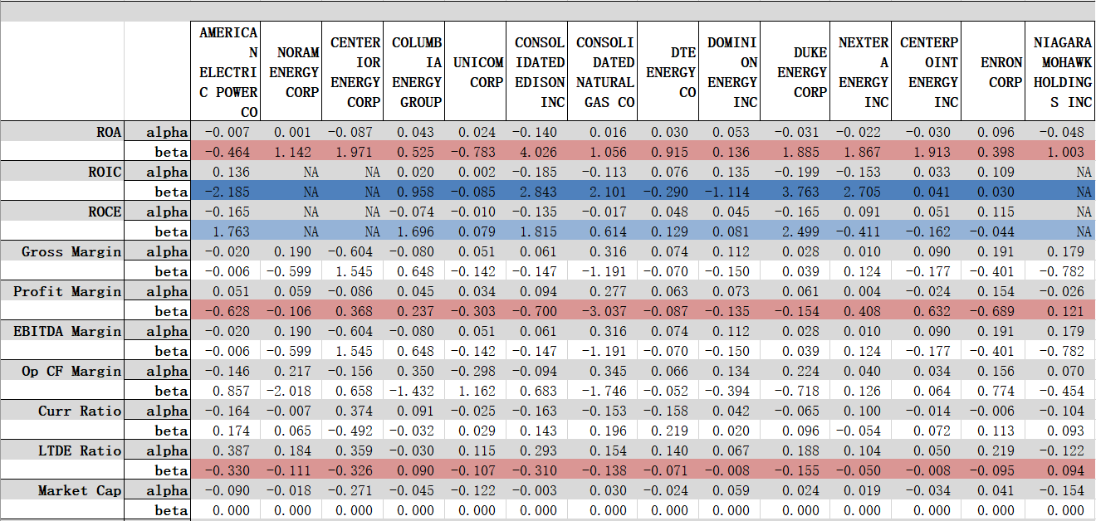

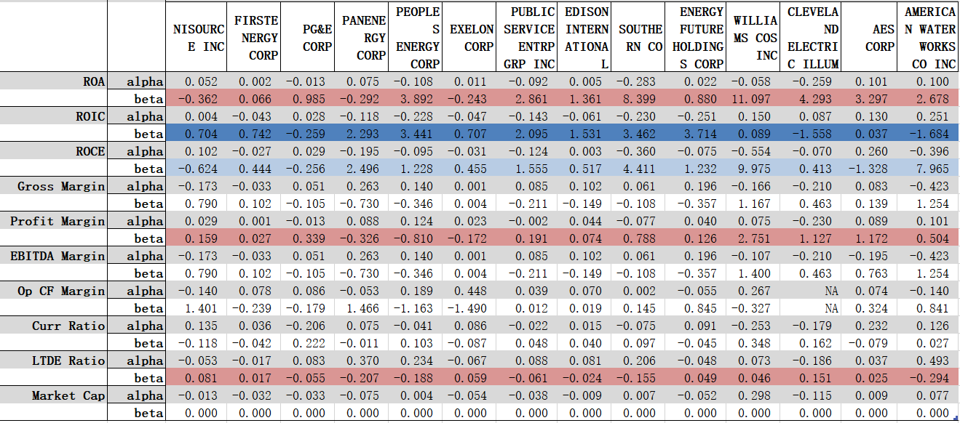

**Regression for Total return:**

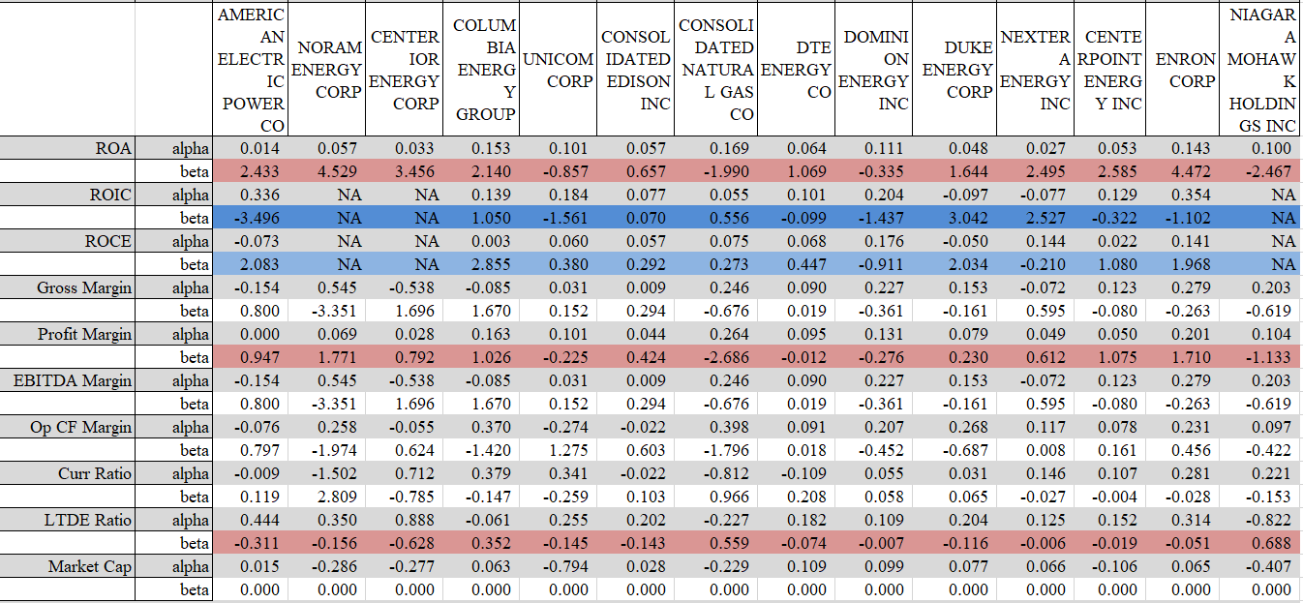

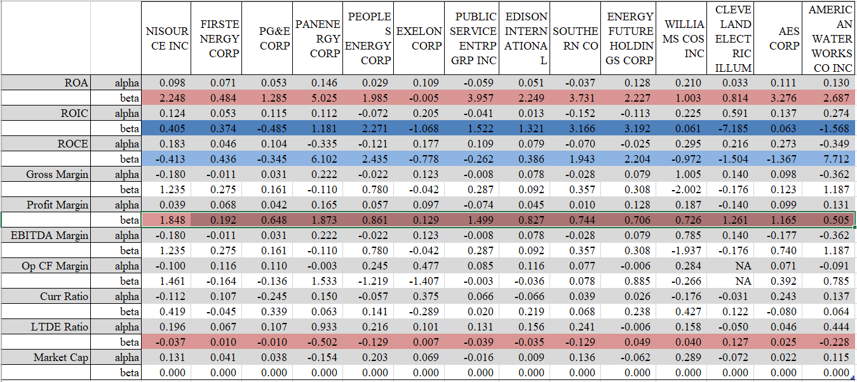

**Next, we run the DW test for the regression residuals:**

The Durbin-Watson test statistic tests the null hypothesis that the residuals from an ordinary least-squares regression are not autocorrelated against the alternative that the residuals follow an AR(1) process. The Durbin-Watson statistic ranges in value from 0 to 4. A value near 2 indicates non-autocorrelation; a value toward 0 indicates positive autocorrelation; a value toward 4 indicates negative autocorrelation. So the DW test results for Price Return vs Fundamental factors and Total Return vs Fundamental factors are listed below. The green cells represent for positive autocorrelation and red for negative autocorrelation.

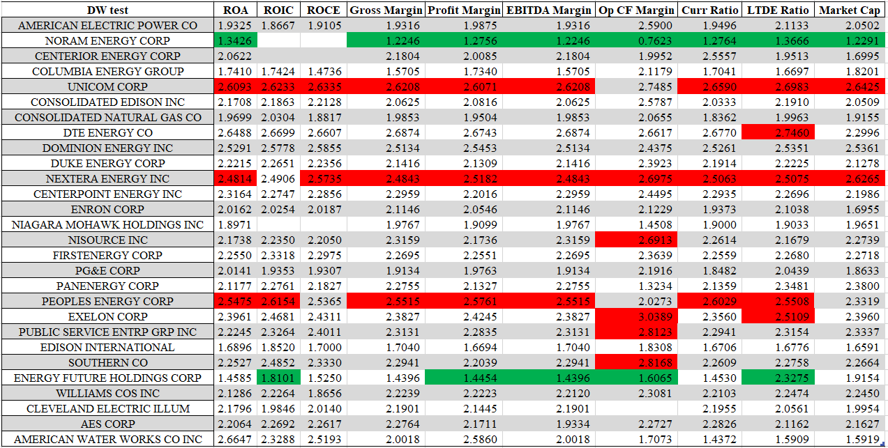

**Price Return DW test**

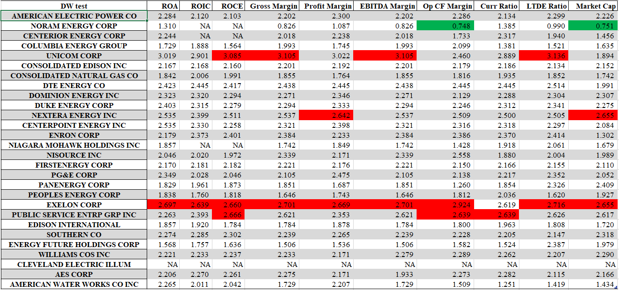

**Total Return DW test**

Based on the comparison of DW statistics vs Critical value, we can see that most of the regression residuals don’t have positive or positive autocorrelation property. So the fundamental factors should have a relatively good proportionally explain effect for the total return or price return.